DESIGN AND ANALYSIS ALGORITHM
Name: G.Ragavendar
Roll no:ch.sc.u4cse24260
1) Sum of first n natural numbers using user-defined function
Code:
#include <stdio.h>
int sumN(int n) {
int sum = 0;
for(int i = 1; i <= n; i++)
sum += i;
return sum;
}
int main() {
int n;
printf("Enter n: ");
scanf("%d", &n);
printf("Sum = %d", sumN(n));
return 0;
}
Output: 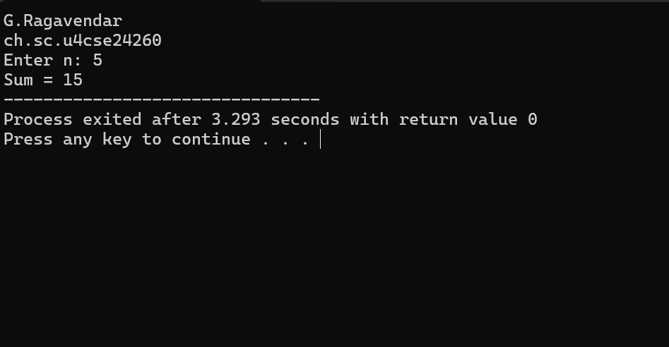

Time Complexity:
Loop runs from 1 to n → O(n)

Space Complexity:
Only variables n and sum → O(1)
2: Sum of squares of first n natural numbers
Code:
#include <stdio.h>
int sumSquares(int n) {
int sum = 0;
for(int i = 1; i <= n; i++)
sum += i * i;
return sum;
}
int main() {
int n;
printf("Enter n: ");
scanf("%d", &n);
printf("Sum of squares = %d", sumSquares(n));
return 0;
}
Output:

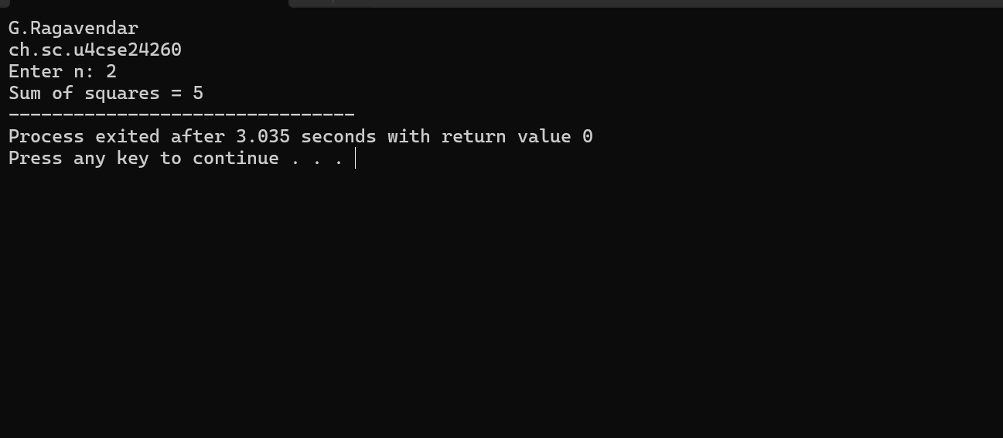

Time Complexity
- Loop runs n times → O(n)

Space Complexity
- Constant extra variables → O(1)
3) Sum of cubes of first n natural numbers
Code:
#include <stdio.h>
int sumCubes(int n) {
int sum = 0;
for(int i = 1; i <= n; i++)
sum += i * i * i;
return sum;
}
int main() {
int n;
printf("Enter n: ");
scanf("%d", &n);
printf("Sum of cubes = %d", sumCubes(n));
return 0;
}
OUTPUT:
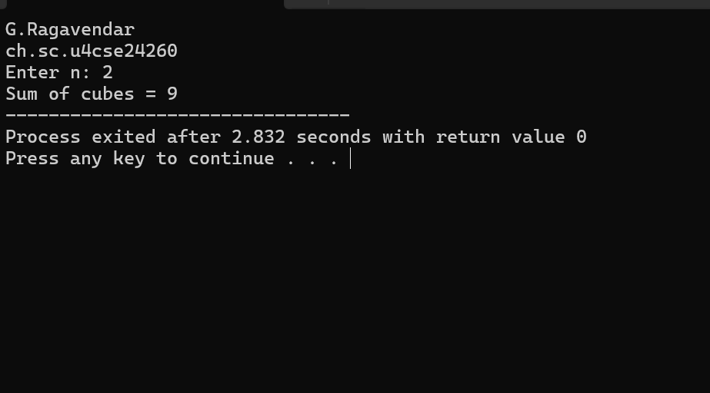

Time Complexity
- Loop runs n times → O(n)

Space Complexity
- Constant memory → O(1)
4) Factorial of a number using recursive function
Code:
#include <stdio.h>
int fact(int n) {
if(n == 0) return 1;
return n * fact(n - 1);
}
int main() {
int n;
printf("Enter number: ");
scanf("%d", &n);
printf("Factorial = %d", fact(n));
return 0;
}
Result:
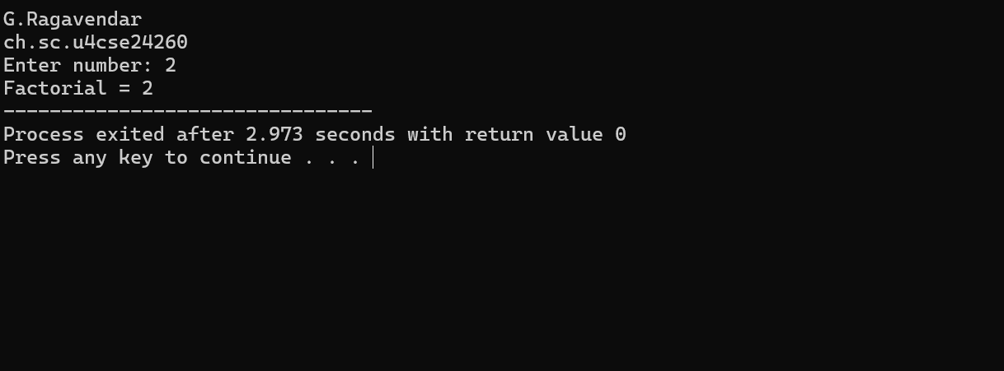

Time Complexity
- Recursion depth = n
- Each call takes constant time → O(n)

Space Complexity
- Recursive stack uses n frames → O(n)
5) Program to transpose a 3×3 matrix
Code:
#include <stdio.h>
int main() {
int a[3][3], t[3][3];
printf("Enter 3x3 matrix:\n");
for(int i = 0; i < 3; i++)
for(int j = 0; j < 3; j++)
scanf("%d", &a[i][j]);
for(int i = 0; i < 3; i++)
for(int j = 0; j < 3; j++)
t[j][i] = a[i][j];

printf("Transpose:\n");
for(int i = 0; i < 3; i++){
for(int j = 0; j < 3; j++)
printf("%d ", t[i][j]);
printf("\n");
}
return 0;
}
Result:
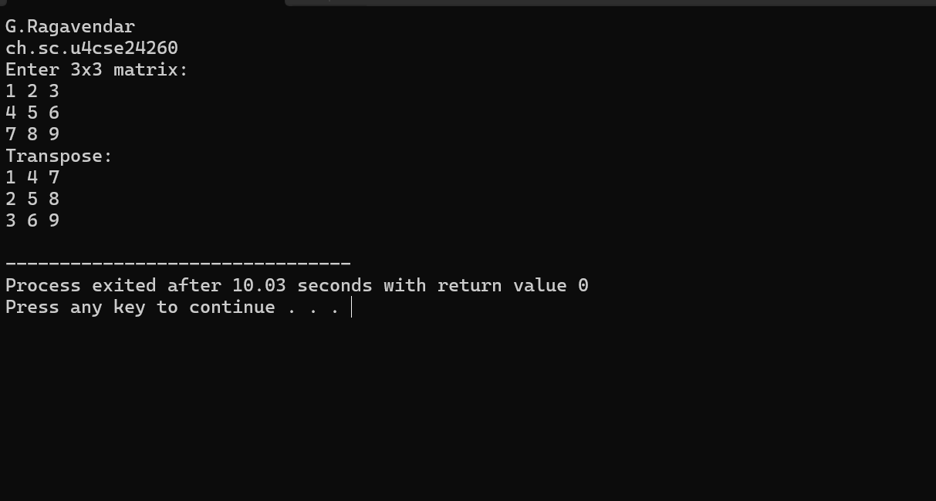
Matrix size is fixed (3×3), so:

Time Complexity
- Always 9 operations → O(1)
(If matrix was N×N → O(n²))

Space Complexity
- Two 3×3 matrices → constant → O(1)
(For N×N → O(n²))
6) Fibonacci series up to n terms (user-defined function)
Code:
#include <stdio.h>
void fibonacci(int n) {
int a = 0, b = 1, c;
if(n >= 1) printf("%d ", a);
if(n >= 2) printf("%d ", b);
for(int i = 3; i <= n; i++) {
c = a + b;
printf("%d ", c);
a = b;
b = c;
}
}
int main() {
int n;
printf("Enter n: ");
scanf("%d", &n);

fibonacci(n);
return 0;
}

Result:
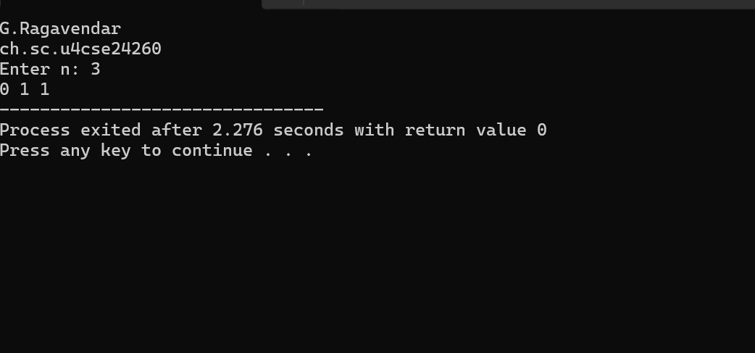

Time Complexity
- Loop runs n times → O(n)

Space Complexity
- Only uses a few variables → O(1)
(Because no recursion, no array)

